S E N D A H O L I D A Y C A R D

FROM THE HEART
T h e S e c o n d H a r v e s t F o o d B a n k o f N o r t h w e s t P e n n s y l v a n i a h a s a h o l i d a y c a r d a v a i l a b l e t o h o n o r t h o s e s p e c i a l p e o p l e o n y o u r l i s t .
The artwork on the 2022 Second Harvest Holiday Card features an array of utensils woven together to form a tree of hope. When lives intertwine during this special season, hope is the only unifying gift. As we near the
end of another difficult year, this gift is desperately needed by so many. Help to bring joy to someone's life with your generous donation during the magic of this time of year. Please choose your option below and
return the form to us by December 19, 2022. With option two, your card(s) may be picked up Monday
through Friday from 8:00 am to 4:00 pm. Cards must be picked up by 12:00 pm on December 22,
OPTION 1 OPTION 2

Send your donation* to Second
Harvest and we will mail the holiday card(s) for you.
*Minimum $20 donation per card
equals 120 meals for our neighbors in need.
Your card(s) are purchased* at Second Harvest to deliver
on your own.
*Minimum $15 donation per card equals 90 meals for our neighbors in need.

Option 1: Option 2:
Donation Amount:
Number of Cards:

Your Name: Your Phone Number:

Your Address:

City:
State:
Zip Code:

Send Card To (Please use the back of this sheet to list additional orders):

Your Name:

Your Address:

City:
State:
Zip Code:

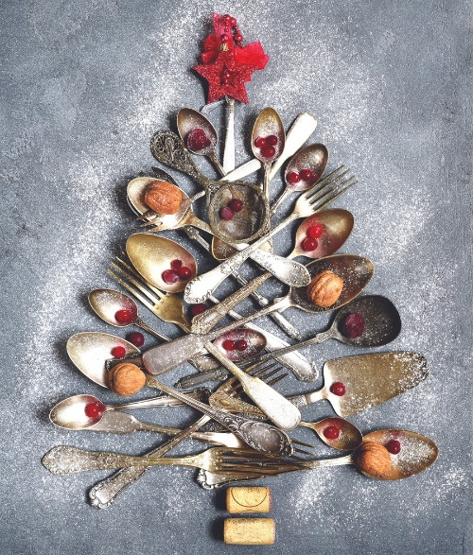
Additional Message:

Checks should be made payable to Second Harvest Food Bank of Northwest Pennsylvania and mailed to 1507 Grimm Drive, Erie PA 16501

