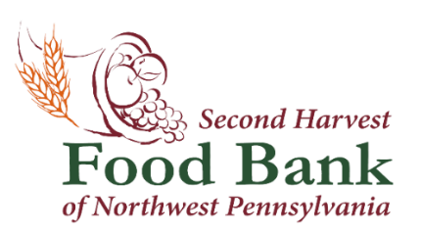

Contact: Natalie E. Massing Second Harvest Food Bank of NW PA
Marketing & Media Coordinator 1507 Grimm Drive
nmassing@nwpafoodbank.org Erie, PA 16501
(814) 459-3663 x 104 www.nwpafoodbank.org

The Legislative Challenge is Back! Join our Local Legislators at Second Harvest Food Bank of Northwest Pennsylvania.

August 11, 2023 – Second Harvest Food Bank of Northwest Pennsylvania will be hosting the eighth annual Legislative Challenge on Monday, August 14th at 4:30 p.m. at our warehouse located at 1507 Grimm Drive, Erie, PA 16501.

Several local Pennsylvania legislators and their staff will be participating in a friendly competition to benefit our neighbors in need. Each team will be given a volunteer activity and the team to pack the most product for distribution will be the Legislative Challenge Champion.

Legislative offices that are participating in the challenge include: Senator Dan Laughlin; Representative Harkins; Office of Representative Banta; Office of Senator Fetterman, Office of Representative Merski, and members of Erie County Council.

Second Harvest Food Bank is looking forward to the return of this wonderful in-person event!

Here is the agenda for the challenge:

- Doors open at 4:00 p.m.
- Legislative contest from 4:30-6:00 p.m.
- Refreshments from 6:00-6:30 p.m.

####

About the Second Harvest Food Bank of Northwest Pennsylvania
The mission of the Second Harvest Food Bank of Northwest Pennsylvania is to provide food to those in need within 11 counties of northwest Pennsylvania while creating awareness and educating the community on the realities of hunger. Last year, Second Harvest distributed over
11.5 million pounds of food through an anti-hunger network of 376 partner organizations. Second Harvest serves the following 11 counties in northwest Pennsylvania: Cameron, Clarion, Clearfield, Crawford, Elk, Erie, Forest, Jefferson, McKean, Venango and Warren.

