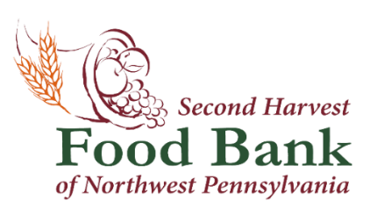

Contact: Natalie E. Massing Second Harvest Food Bank of NW PA
Marketing & Media Coordinator 1507 Grimm Drive
nmassing@nwpafoodbank.org Erie, PA 16501
(814) 459-3663 x 104 www.nwpafoodbank.org

Second Harvest Food Bank of Northwest Pennsylvania Partners with DoorDash for Monthly Senior Food Box Distribution

July 31, 2023 – Second Harvest Food Bank of Northwest Pennsylvania has recently begun offering home delivery of monthly Commodity Supplemental Food Program (CSFP) senior food boxes in the Oil City/Franklin area.

As the first food bank in Congressional District 15 (PA-15) to offer CSFP home delivery, Second Harvest Food Bank staff members and the Project DASH DoorDash team will be joined by Brad Moore, District Director at the Office of U.S. Representative Glenn Thompson (PA-15), and Sheila Christopher, Executive Director of Hunger-Free PA, for this once a month distribution event to see firsthand how partnerships with companies like DoorDash improve food access.

Please join us at Christ United Methodist Church at 1135 Buffalo Street in Franklin, PA, Tuesday, August 1st, at 11:45 am until delivery cars depart at 12:30 pm.

####

About the Second Harvest Food Bank of Northwest Pennsylvania
The mission of the Second Harvest Food Bank of Northwest Pennsylvania is to provide food to those in need within 11 counties of northwest Pennsylvania while creating awareness and educating the community on the realities of hunger. Last year, Second Harvest distributed over
11.5 million pounds of food through an anti-hunger network of 376 partner organizations. Second Harvest serves the following 11 counties in northwest Pennsylvania: Cameron, Clarion, Clearfield, Crawford, Elk, Erie, Forest, Jefferson, McKean, Venango and Warren.

