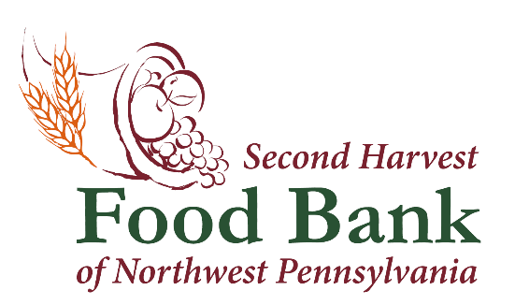

Second Harvest Food Bank of Northwest Pennsylvania Joins Feeding America for Hunger Action Day

September 13, 2023 – Hunger Action Day is this Friday, September 15, 2023. Second Harvest Food Bank of Northwest Pennsylvania will join Feeding America and other network member food banks to inspire people to act and raise awareness of those facing food insecurity. Food banks around the country are working to make a real and lasting impact in their communities and they are asking for the public’s support.

Orange is the color of hunger relief. During Hunger Action Day, let’s join together by wearing orange and raising our voices all across the country on behalf of the millions of people facing food insecurity. September 15th is a day where collective efforts across the country are focused for greater impact.

Also, in the month of September, people across northwest Pennsylvania can get involved in the movement be learning, committing, and speaking up about the ways to end hunger. You can get involved by:
- Donating to Second Harvest Food Bank of Northwest Pennsylvania at nwpafoodbank.org.
- Volunteer at the warehouse, office, or other areas in our service area for Second Harvest of Northwest Pennsylvania.
- Follow and share Second Harvest Food Bank of NW PA on our social media sites.

###
About Feeding America

Feeding America is committed to an America where no one is hungry. We support tens of millions of people who experience food insecurity to get the food and resources they say they need to thrive as part of a nationwide network of food banks, statewide food bank associations, food pantries and meal programs. We also invest in innovative solutions to increase equitable access to nutritious food, advocate for legislation that improves food security and work to address factors that impact food security, such as health, cost of living, and employment.
We partner with people experiencing food insecurity, policymakers, organizations, and supporters, united with them in a movement to end hunger. Visit FeedingAmerica.org to learn more.

About the Second Harvest Food Bank of Northwest Pennsylvania
The mission of the Second Harvest Food Bank of Northwest Pennsylvania is to provide food to those in need within 11 counties of northwest Pennsylvania while creating awareness and educating the community on the realities of hunger. Last year, Second Harvest distributed over
11.5 million pounds of food through an anti-hunger network of 376 partner organizations. Second Harvest serves the following 11 counties in northwest Pennsylvania: Cameron, Clarion, Clearfield, Crawford, Elk, Erie, Forest, Jefferson, McKean, Venango and Warren.

Press Contact:
Natalie E. Massing
Marketing & Media Coordinator
nmassing@nwpafoodbank.org
814-459-3663 x 104

